Megan Pokal
DSC 650 – Big Data
Nasheb Ismaily
February 16, 2026

Week 9 Assignment: Exploring Apache NiFi

Objective 1 - Conceptual Foundations:

Link: https://youtu.be/YiCo70SV2O8

Nifi Overview
Apache Nifi is a visual data tool that moves and manages data between different systems such as files, APIs, databases, and IoT devices. Users build pipelines by connecting processors on a canvas, where each processor performs a specific task like collecting, transforming, or storing data. Data travels through the system as FlowFiles containing both content and metadata, while queues provide reliability if processing slows down. Nifi can also track data provenance, to see where it came from and how it changed. Nifi has an easy design to monitor reliable big data pipelines.

ETL Process Explained
ETL stands for Extract, Transform, and Load. In Nifi, data can be pulled from many sources. During the transform stages, the data is cleaned, like changing CSV to JSON, converting formats, or removing information, etc. The Load stage sends the processed data to a destination like HDFS and S3. Nifi works in real time and provides a visual interface, making pipelines easier to monitor and troubleshoot.

IoT Example
An IoT example of Apache Nifi is combining health data from different wearable and medical devices. Each device sends data in a different format and protocol. Allowing downstream systems and analytics tools to work with consistent real-time data, without knowing the original location.

The systems show how the different components work together to store, manage, and quickly retrieve large amounts of data fast and easily.

Objective 2 - Environment Initialization:

ssh -L 9870:localhost:9870 -L 8088:localhost:8088 -L 8080:localhost:8080 -L 18080:localhost:18080 -L 16010:localhost:16010 -L 8983:localhost:8983 -L 8443:localhost:8443 meganpokal27@35.236.15.189

1. Environment Initialization
- Change into the nifi directory with
cd dsc650-infra/bellevue-bigdata/nifi

- Start NiFi using the command:
/bin/bash nifi-*/bin/nifi.sh start

With /bin/bash nifi-*/bin/nifi.sh status, it shows that Apache Nifi is currently running.
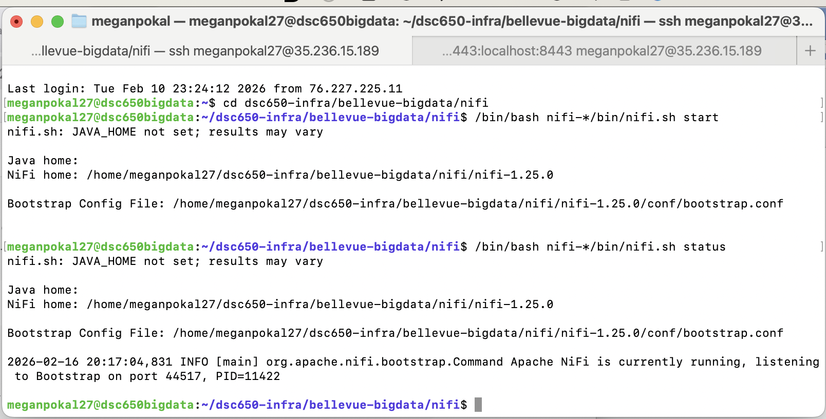

- Access the NiFi User Interface using the instructions in the Week 1 assignment.
Access NiFi UI
From Week 1:
Generated Username [9009a9ba-f6c1-4c75-9ebc-4d2542f19052]
Generated Password [hDNDcLrLWMwR4OxvNcFR+7ls3ZKX9GBu]

Website: https://localhost:8443/nifi/
Login with username and password. With the old username and password, I logged right in with it.

I successfully got into Nifi.

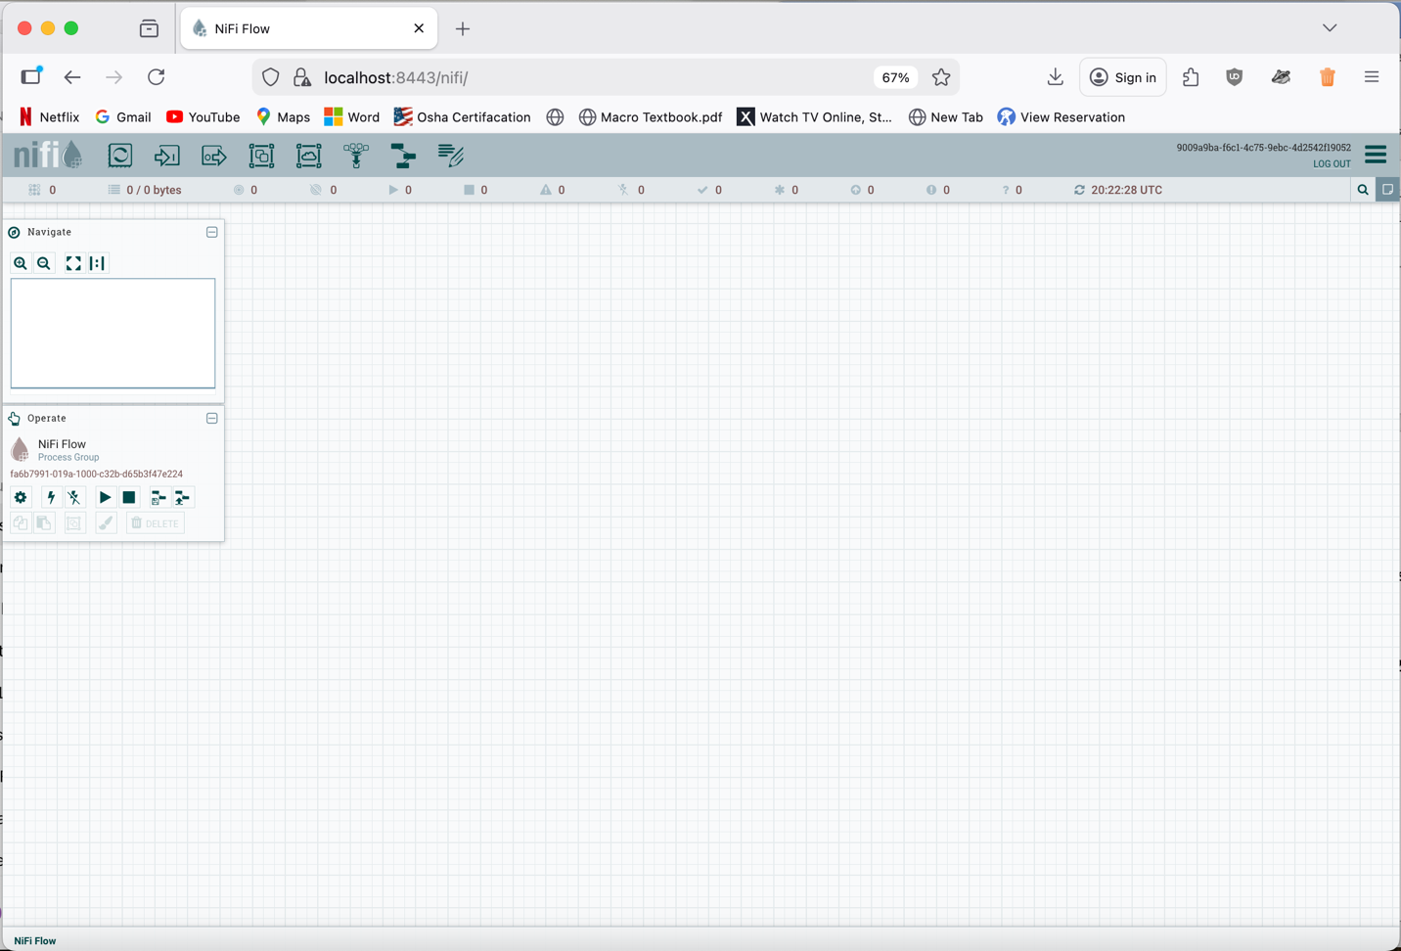

Objective 3 - Creating a Processor Group and Context:

1. Creating a Processor Group
In this section, you will create your first Processor Group in NiFi, which serves as a logical container for grouping processors that will work together to form a data flow.
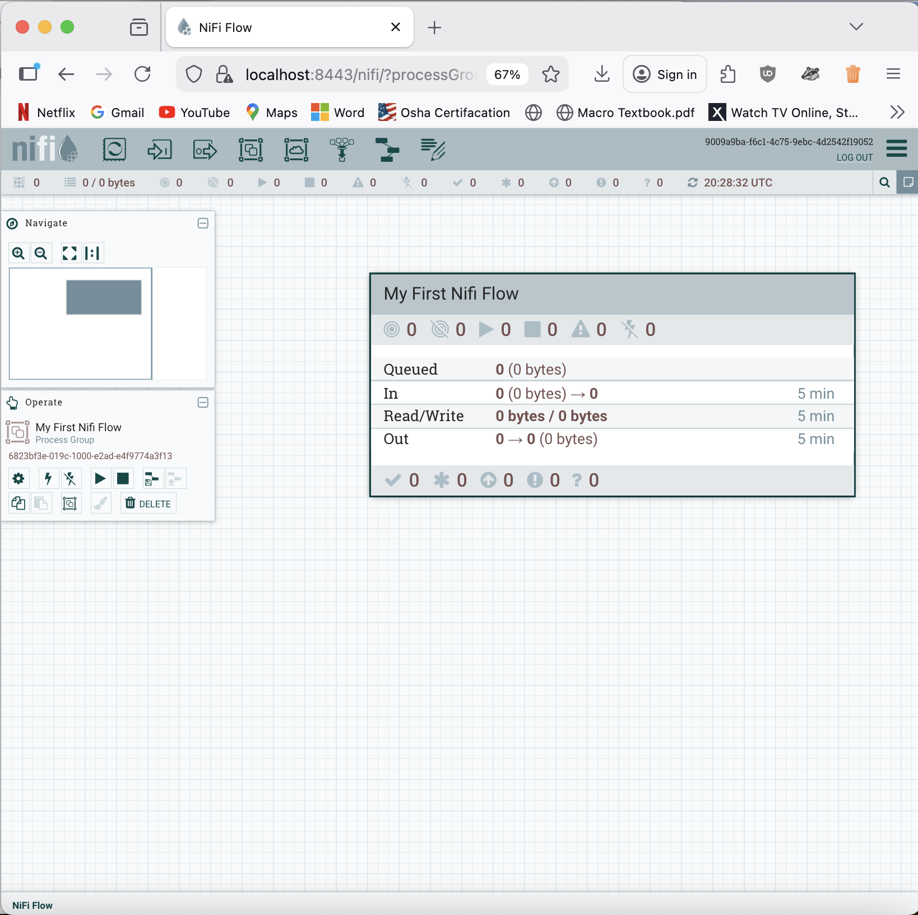

Changed the Process Group Parameter Context to My First Nifi Flow.
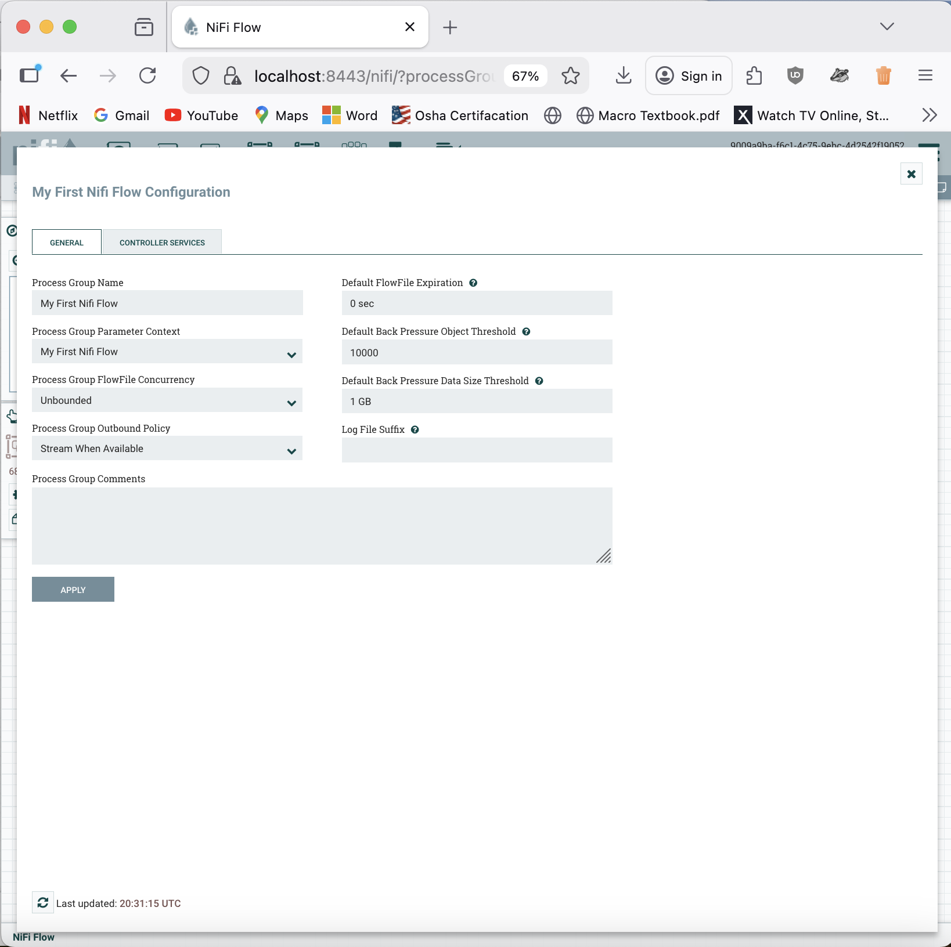

Processor, GenerateFlowFile
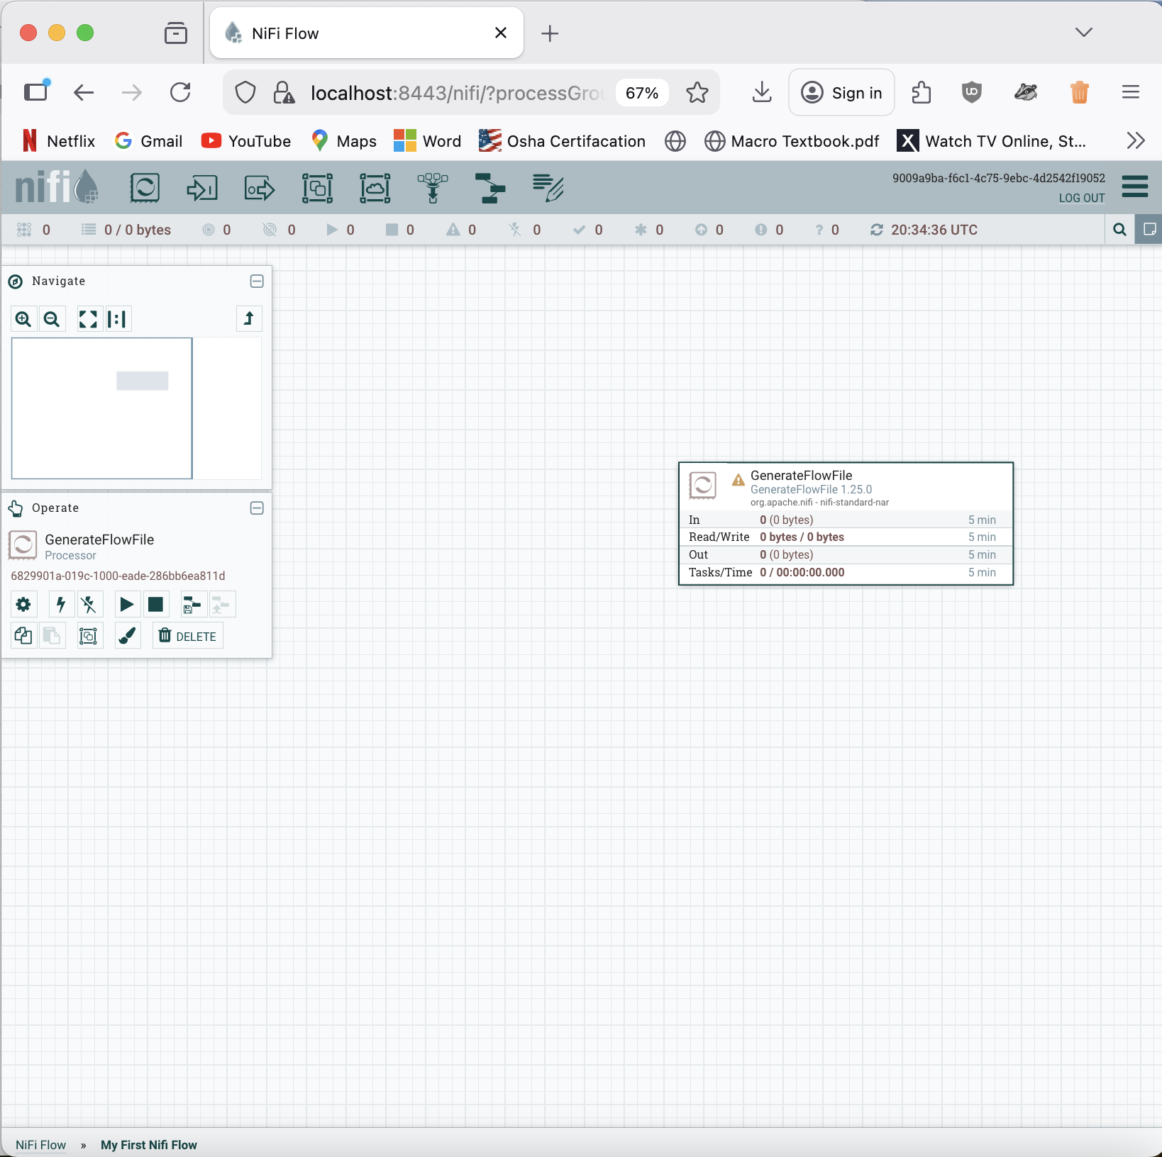

When you first have a processor, you have to configure it.
Configure Processor.
- Run Schedule: 5 seconds
- Property
  - File Size: #{FileSize}
Canvas
- Parameter
  - FileSize
  - 1KB

It successfully created a parameter called FileSize in the Parameter context and assigned it to my process group. This parameter allows me to manage the FlowFile size for all processors in the group, making the flow easier.

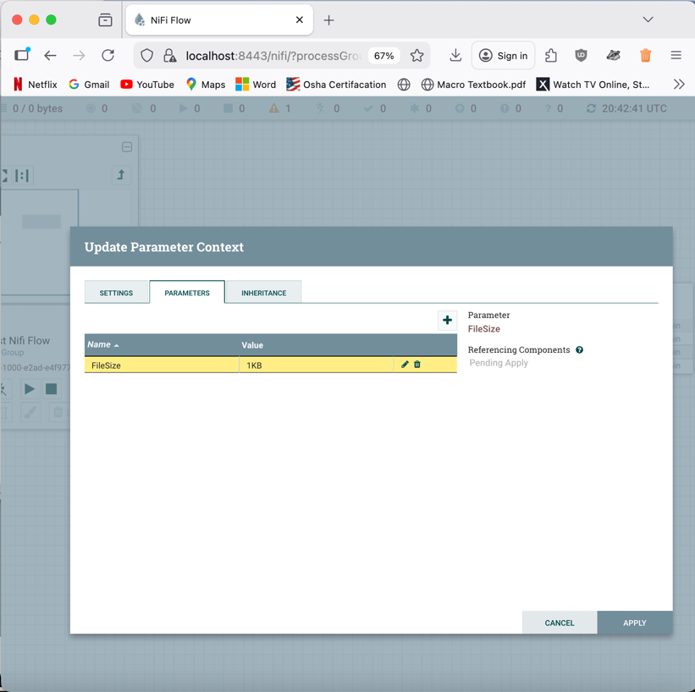

Objective 4 - Designing a Simple Flow:

1. Designing a Simple Flow
In this step, you will design a simple data flow using NiFi processors to generate files and log their attributes. This introduces you to how processors can be linked and configured to automate data processing.

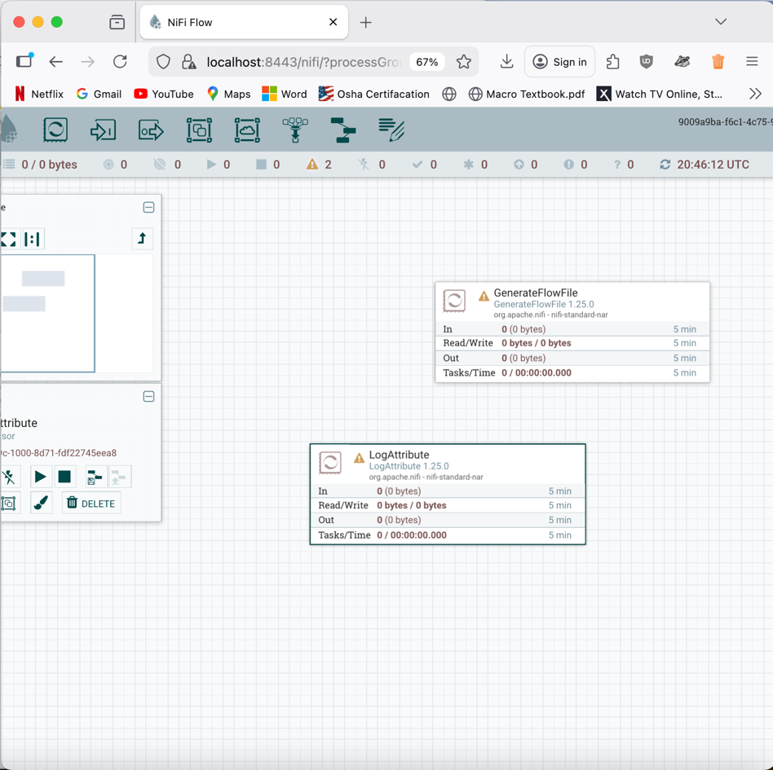

Configure
- Settings
  - Bulletin Level: INFO
- Properties
  - Log Payload: True

Connect the two.
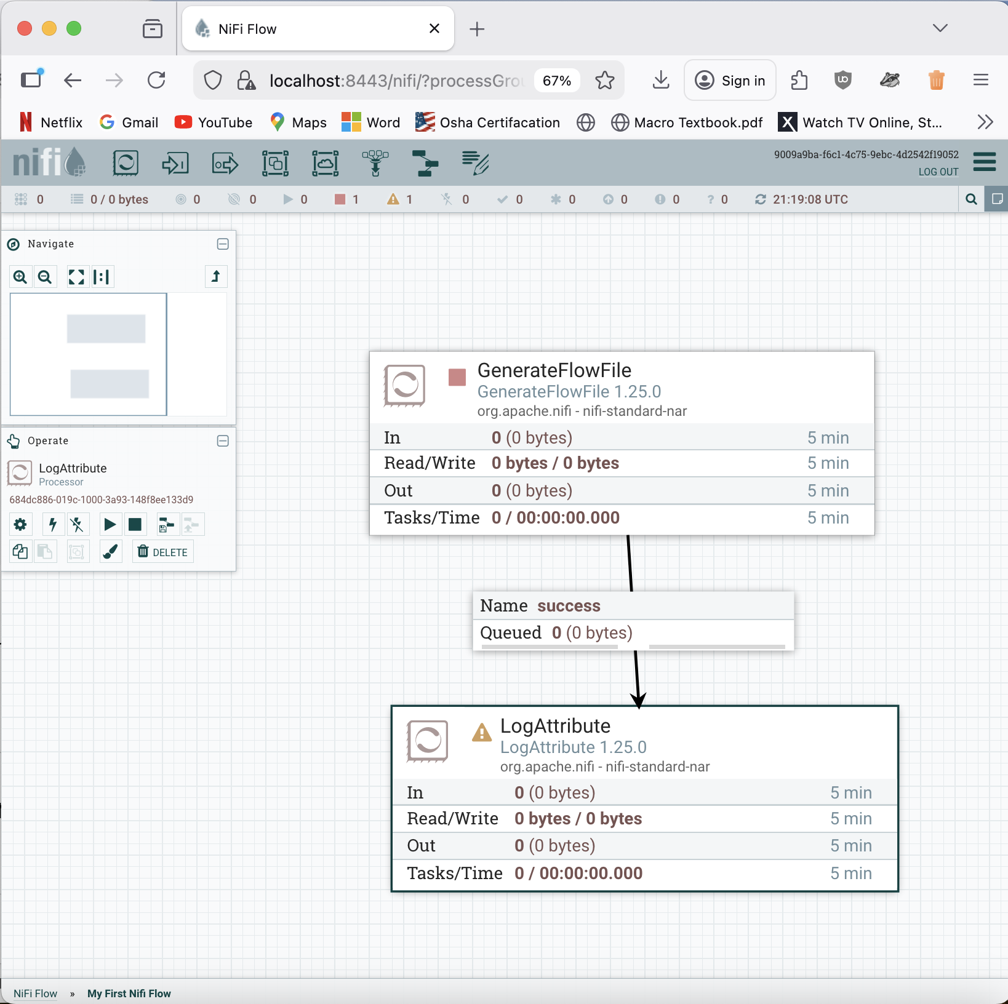

Configure
Relationship - Terminate
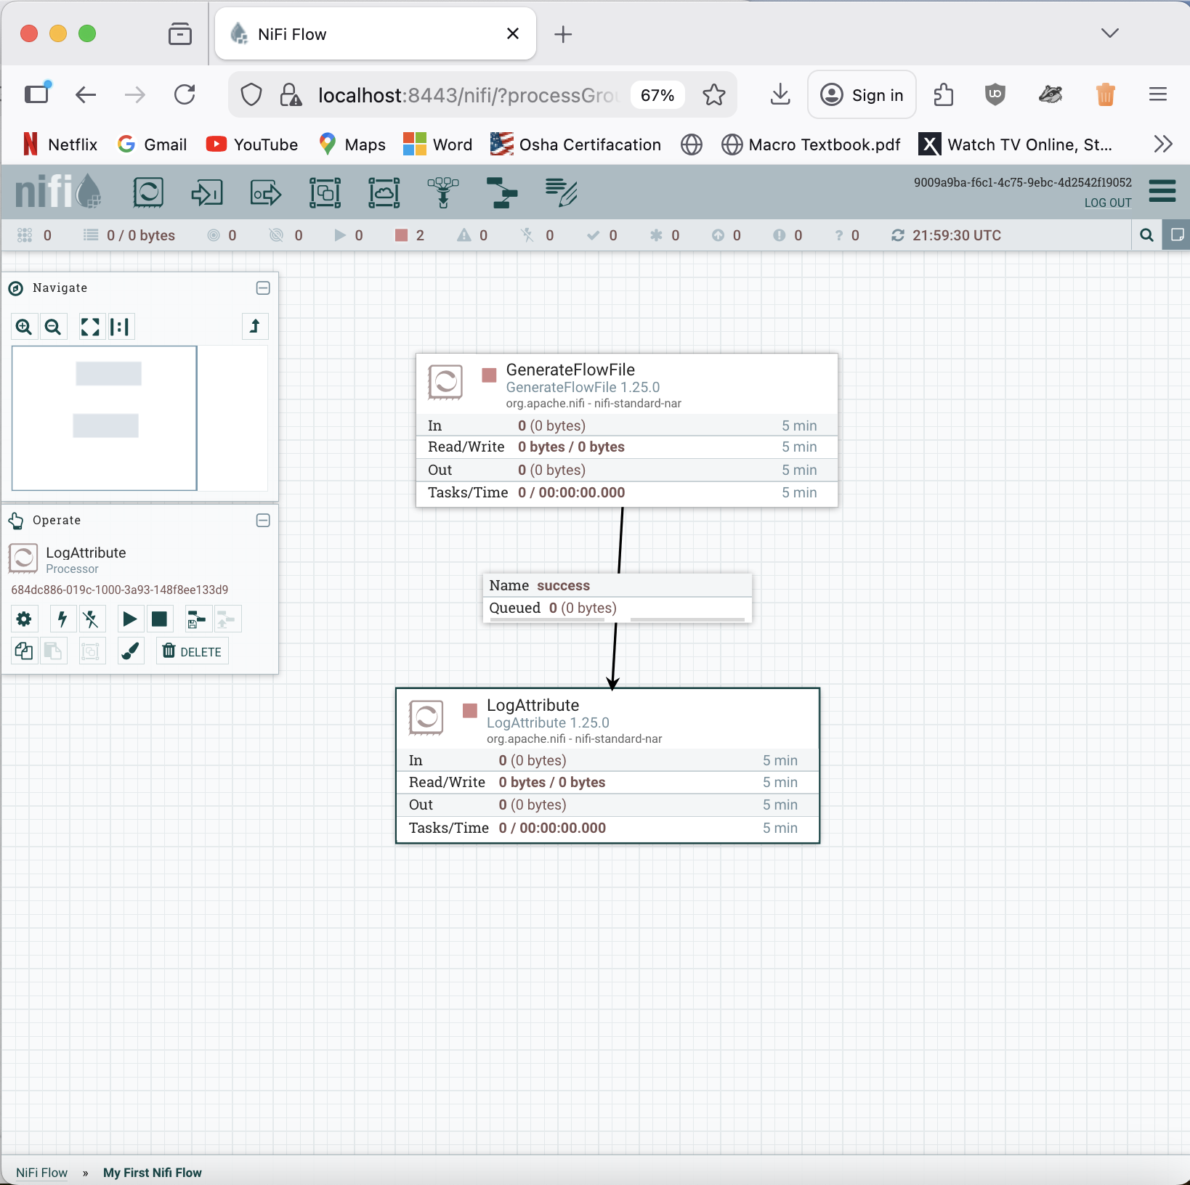

Run Once
Refresh
The data has came through and it is 1 KB.

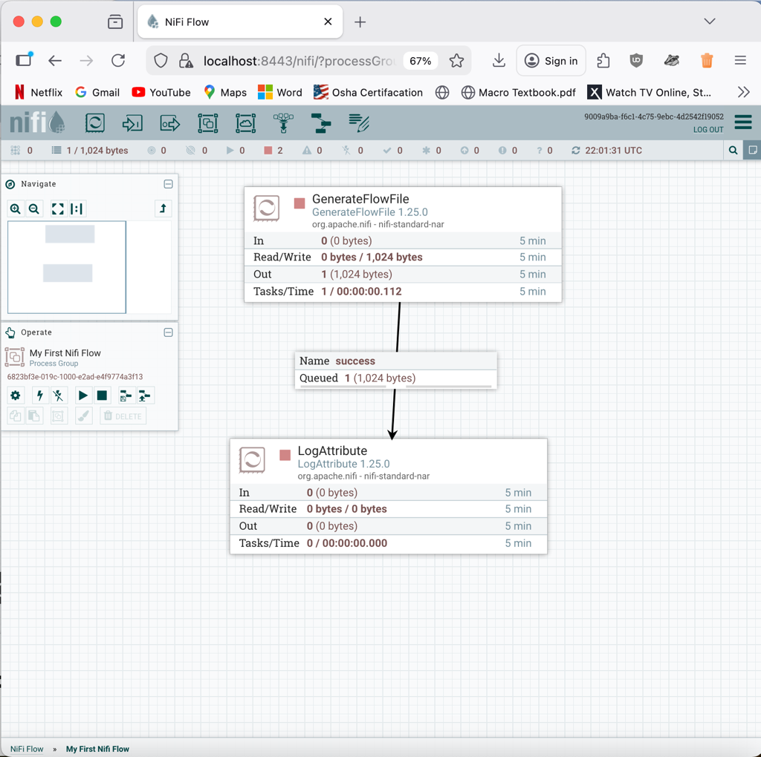

List Queue
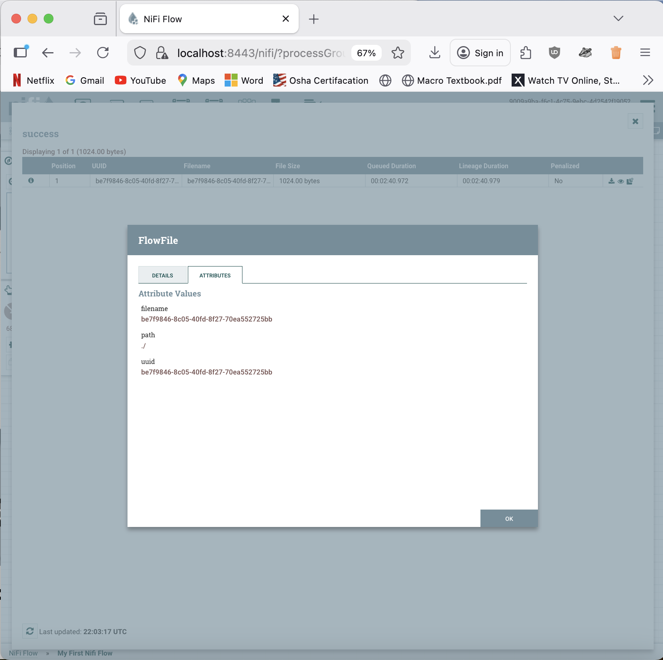

Change to 2KB and run again.

The metadata and the data.

Stop the flow.

This simple flow generates FlowFiles every 5 seconds and logs their attributes using LogAttribute. The output confirms that Nifi is correctly creating FlowFiles and showing the metadata.

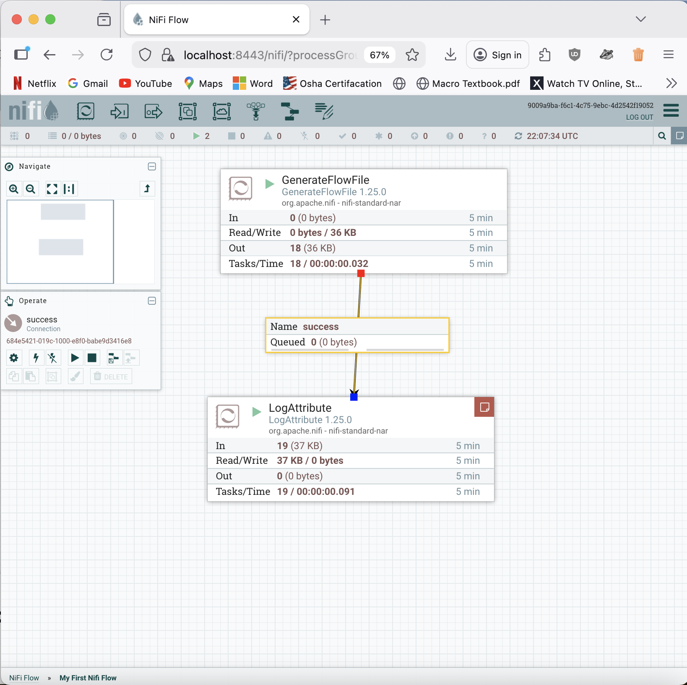

Objective 5 - Setting Up Solr Collection:

1. Setting Up Solr Collection
In this section, you’ll set up a Solr collection to store logs. This will integrate your NiFi flow with Solr, allowing you to push data into a searchable index.

Navigate to the Solr directory and initiate the Solr Docker container, as instructed in the Solr assignment:

cd solr
docker-compose up -d
Create a Solr collection named syslog.
- Enter the Solr docker container:
docker exec -it solr_solr_1 bash
- If you can’t access the Solr container, it could be due to a container name change. In this cause use:

docker exec -it solr-solr-1 bash
- Create the Solr Collection
/opt/solr/bin/solr create -c syslog

The syslog Solr collection has been successfully created. It can store and index log data processed by Nifi. All the logs can be searchable, filtered and queried in Solr now.
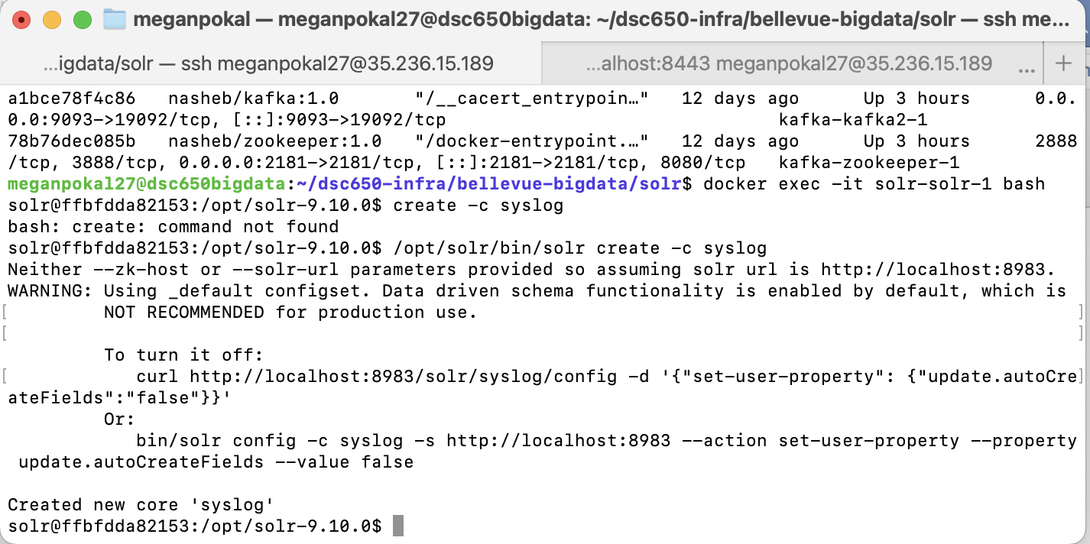
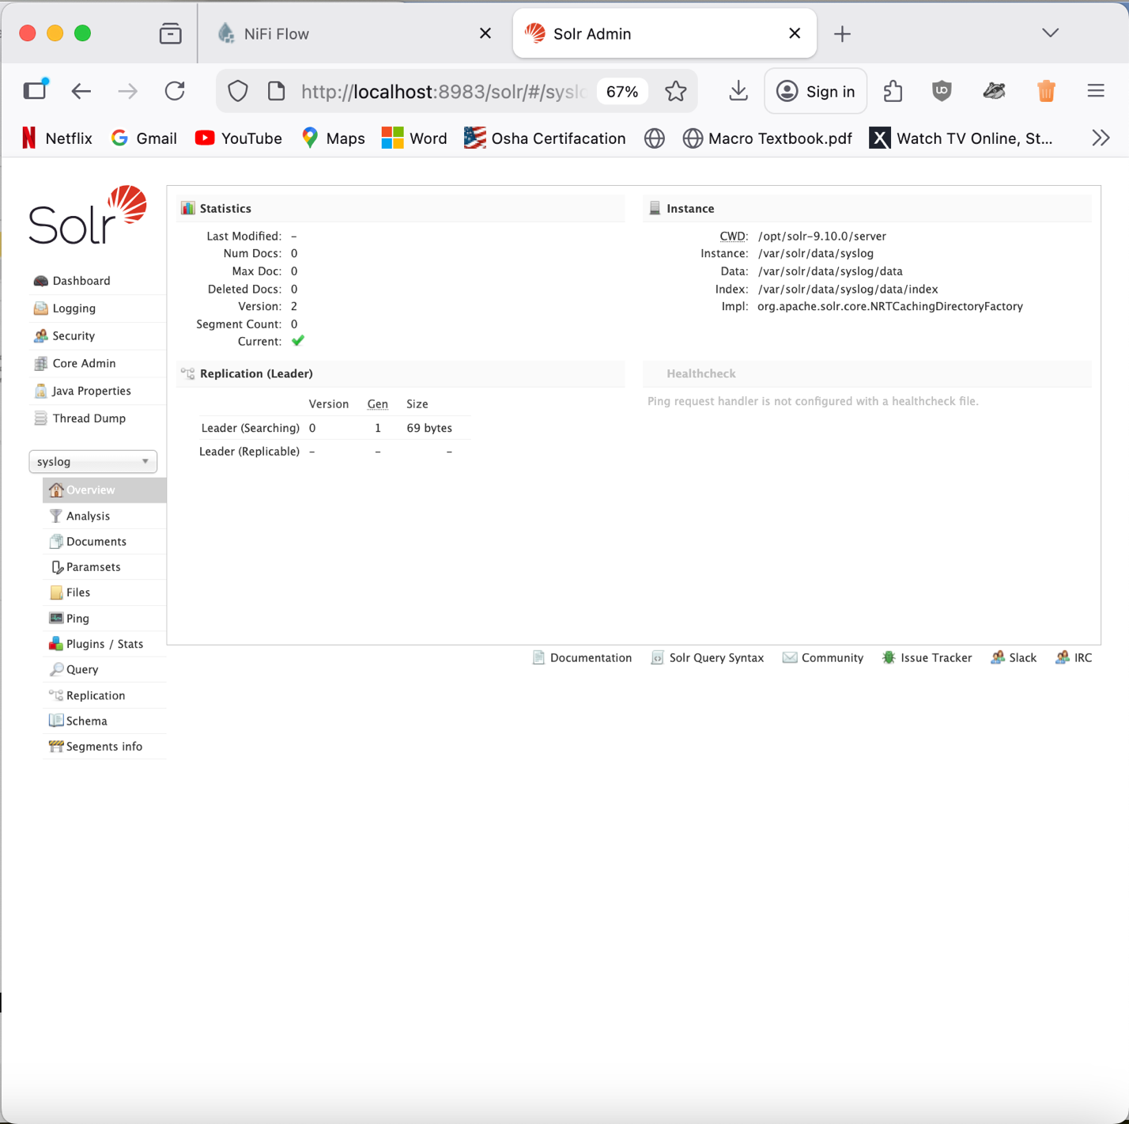

Query data but there isn’t much there. So, we need to add more data into it.

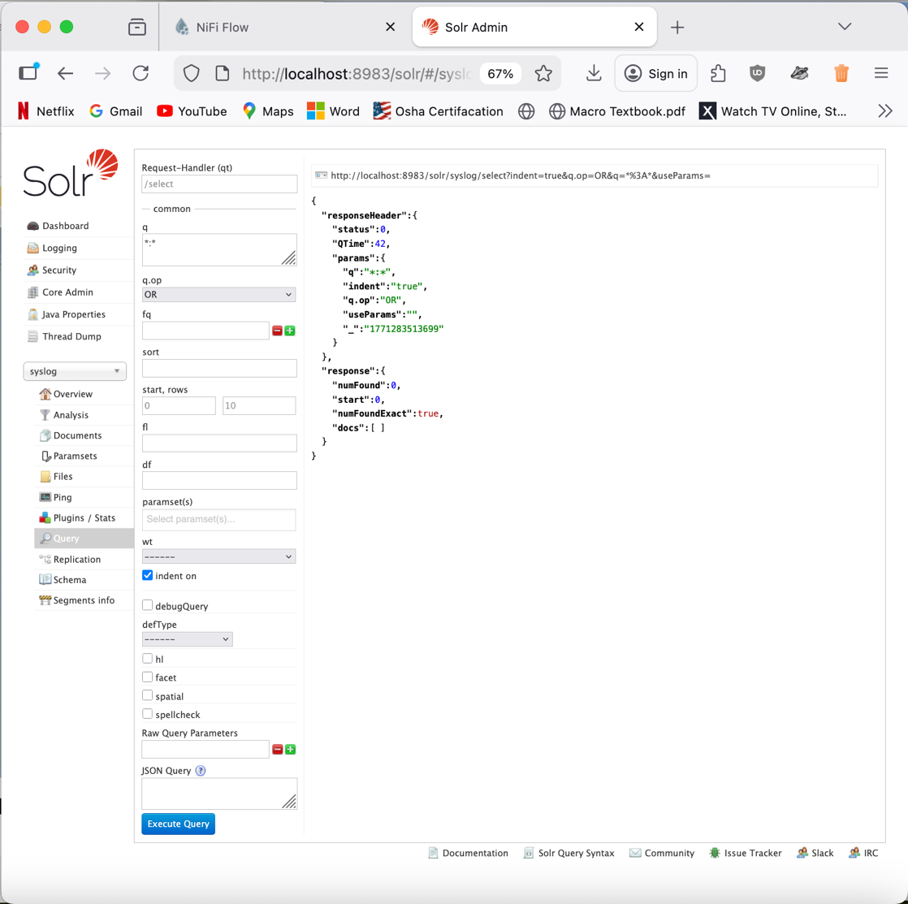

Objective 6 - NiFi Advanced Flow with Solr Integration:

1. NiFi Advanced Flow with Solr
Now, you’ll implement a more advanced data flow that integrates NiFi with Solr for log data processing and storage. You’ll import a pre-built flow to generate, filter, and index logs in Solr.

Nifi Flow
Add Process Group
Import: Syslog_Processing.json
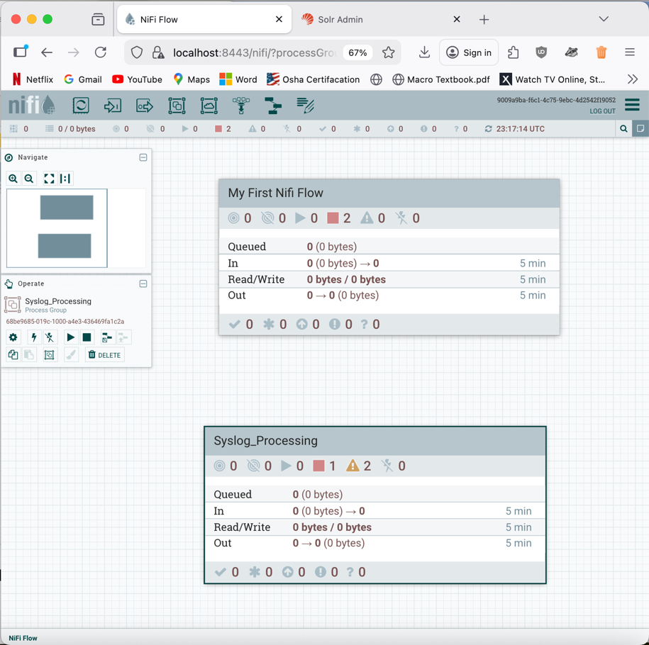

Filter Events

Configure Processor
Properties

Abro registry, enable. This allows us to define a schema on the data.

We already defined the schema. This takes the data that in one format and translates it into a different format.

All four have been enabled now.
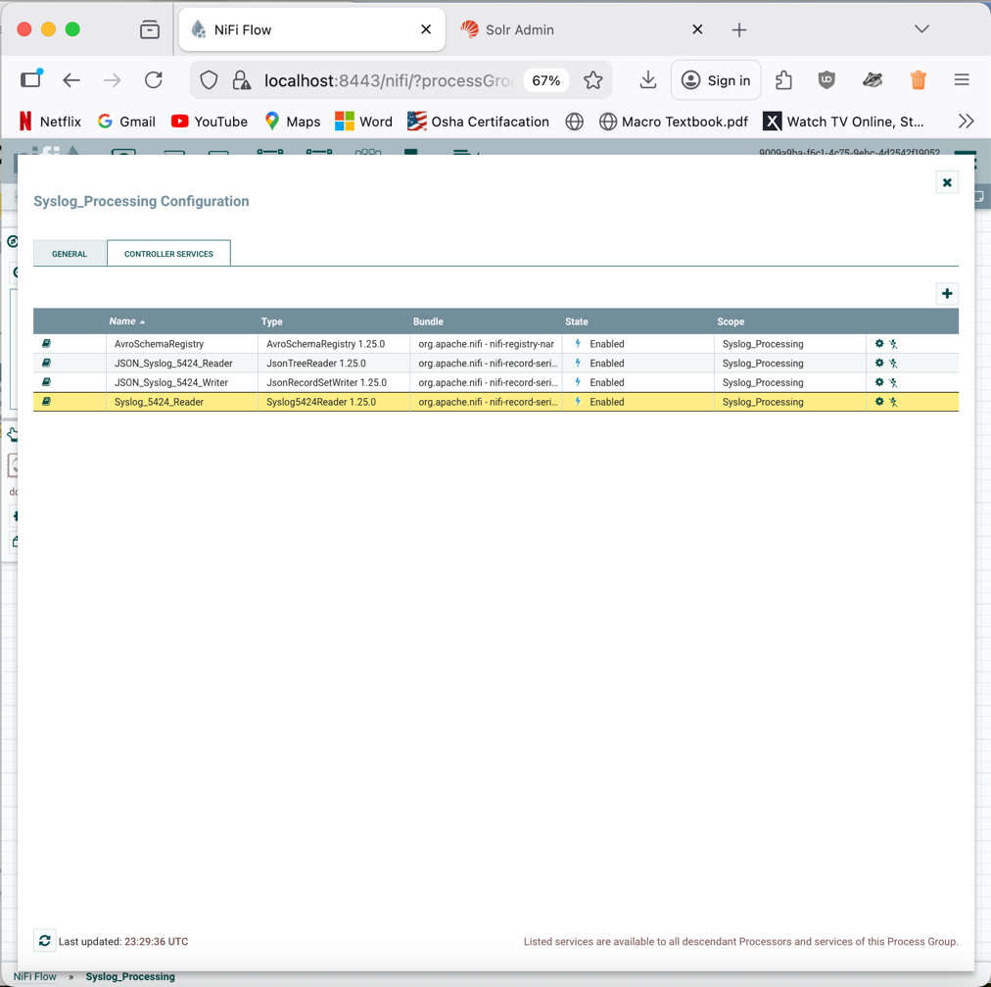

Everything is ready to go now.
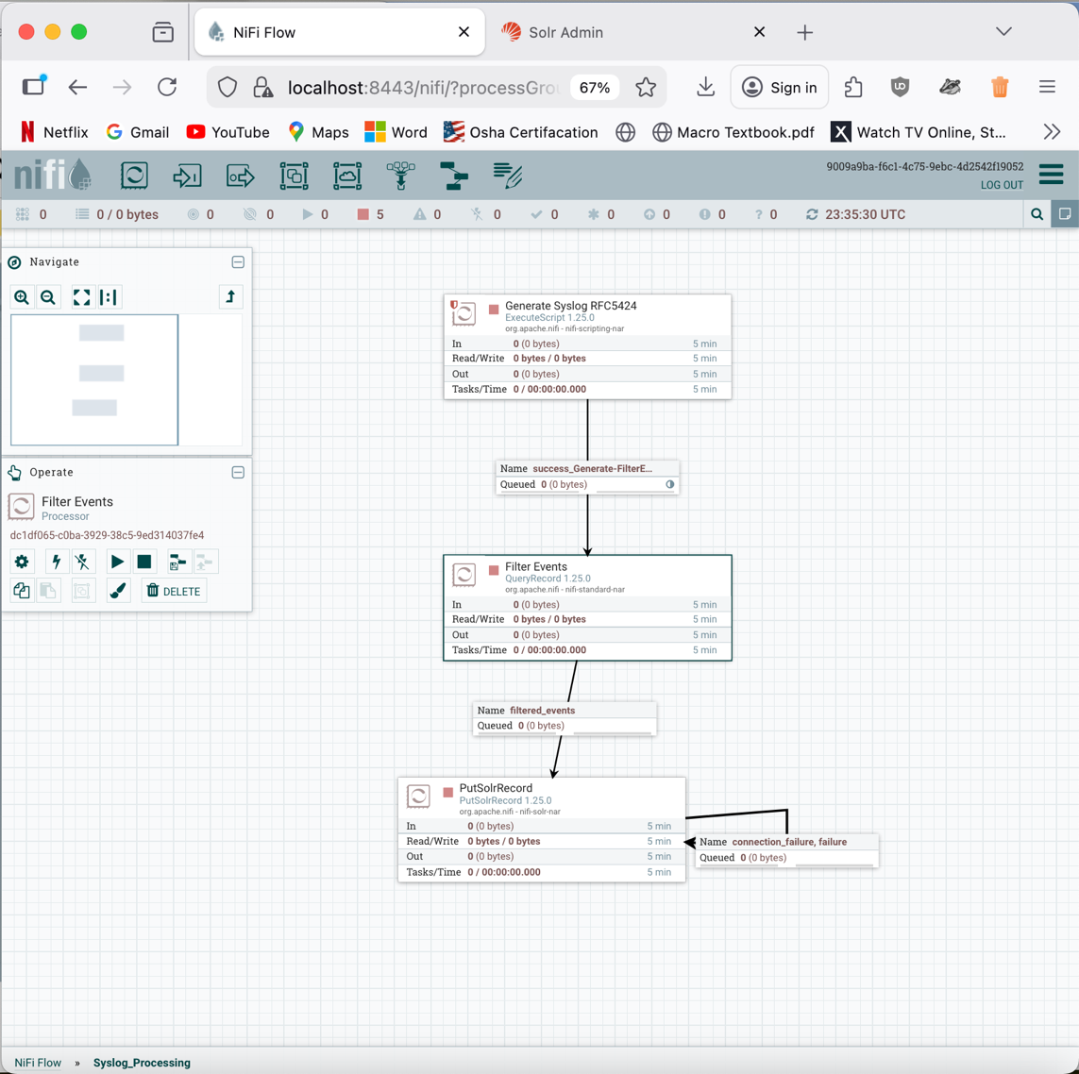

Parameters – are all good.

Generate syslog – Run once and refresh
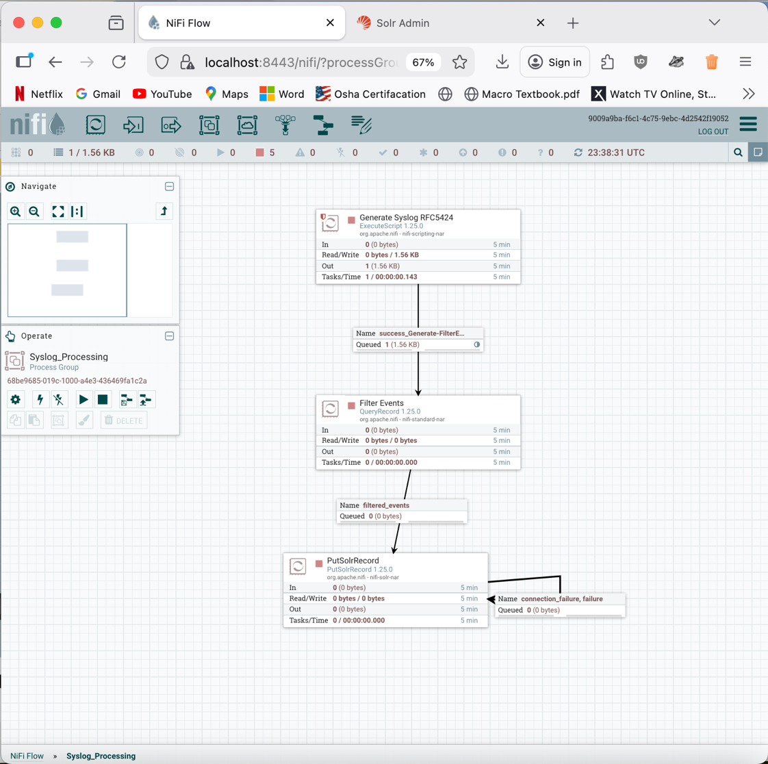

Query records
Record Reader: Syslog_5424_Reader
Record Writer: JSON_Syslog_5424_Writer

Filer Events – Start
Refresh

List Queue
View as Formatted

Syslog data has been converted to JSON.
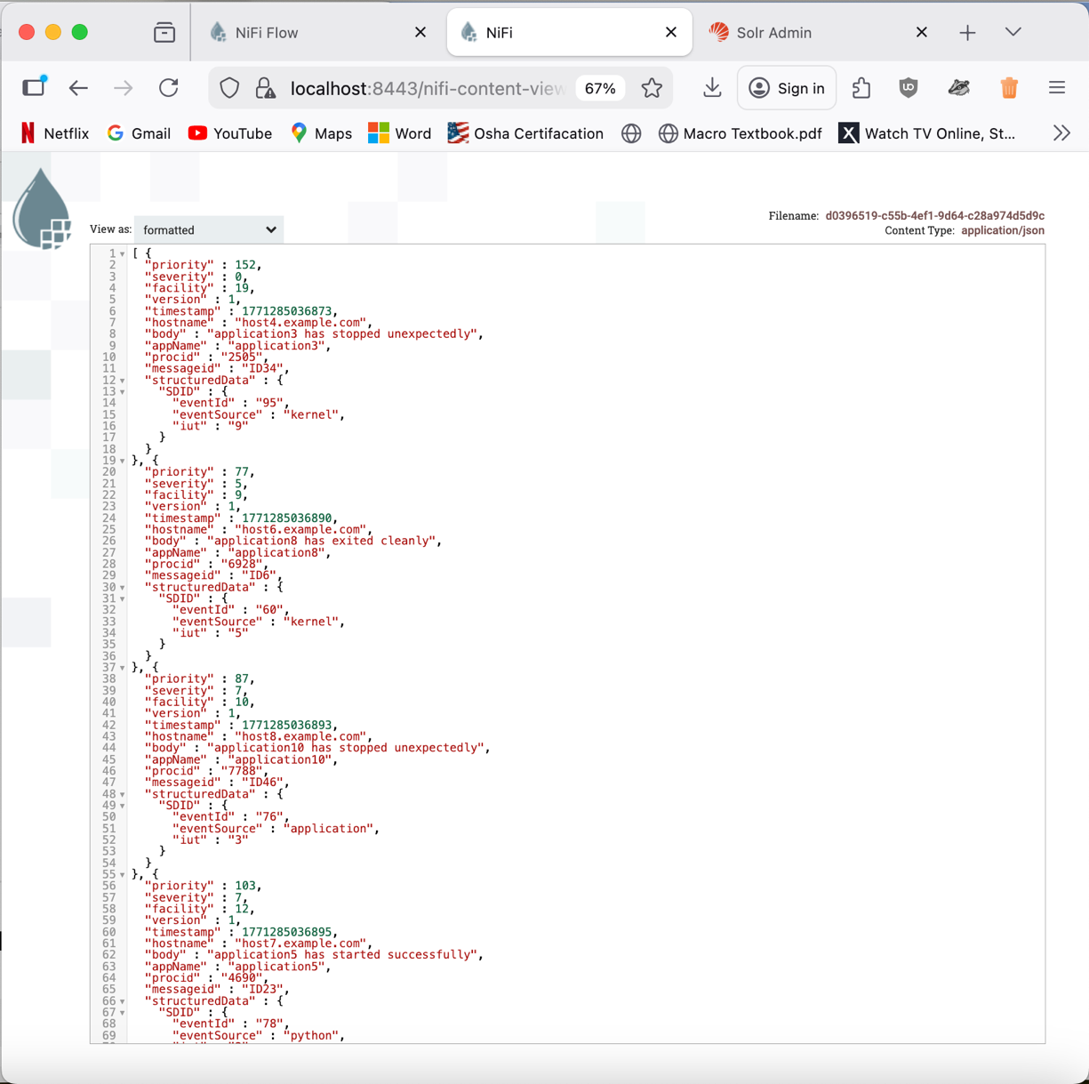

PutSolrRecord – Start

The data is gone and went over to Solr.

The Nifi flow generated the data into Solr automatically. The Solr results confirm that the logs are being processed by Nifi and stored with searchable fields, including timestamps, hostnames and messages.

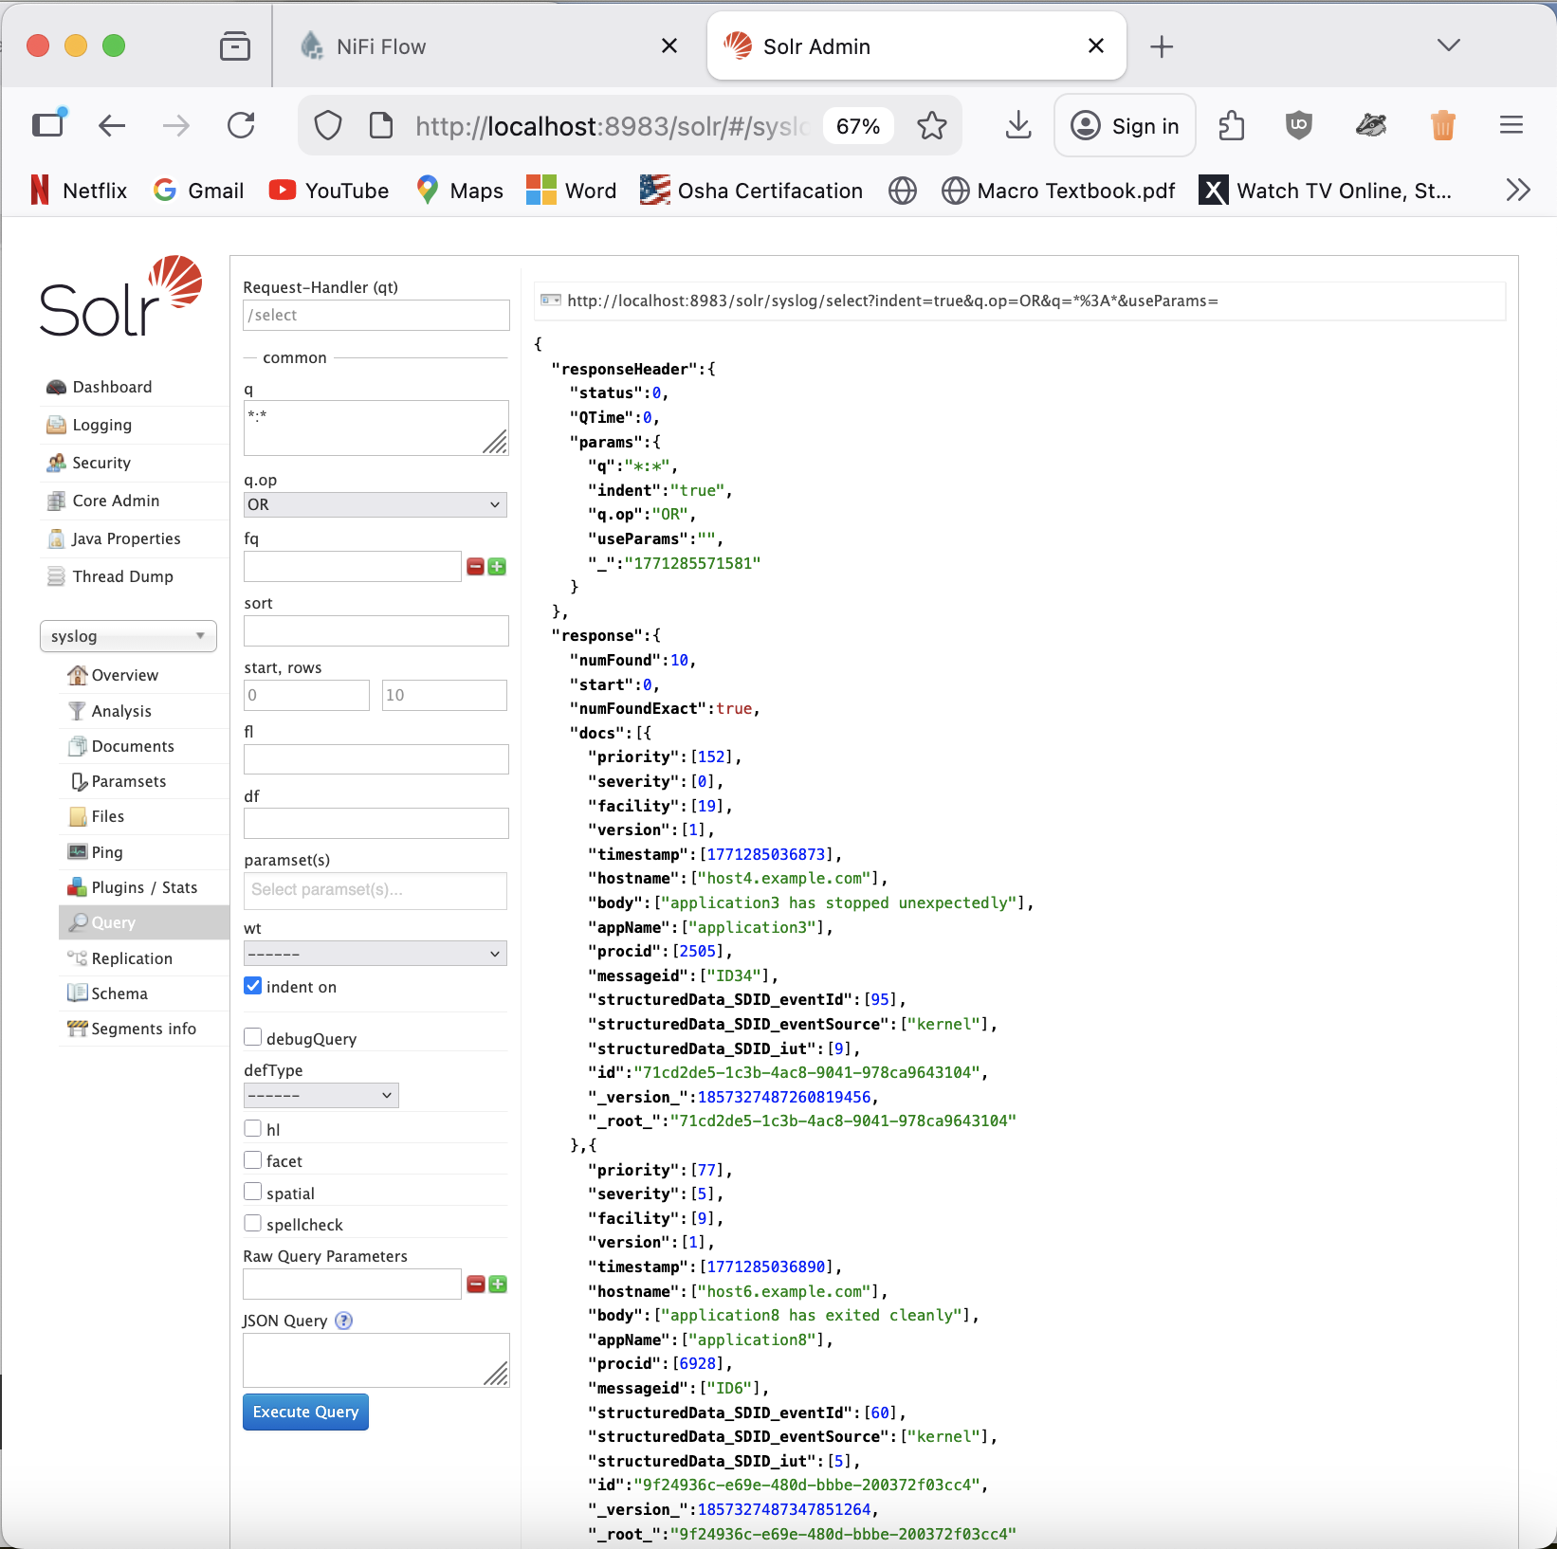

Objective 7 – Querying Solr Data:

1. Querying Solr Data
Finally, you will query the processed data stored in the Solr syslog collection. Use the Solr Web Interface to craft and execute queries, exploring different query parameters and filters.
Access the Solr Web Interface for querying:
Query ‘syslog’ in Solr Web Interface
Follow the link, and you’ll be presented with a user-friendly interface to craft and execute your queries. Experiment with different parameters and filters.
*:* in the q field - means return all documents in the syslog collection
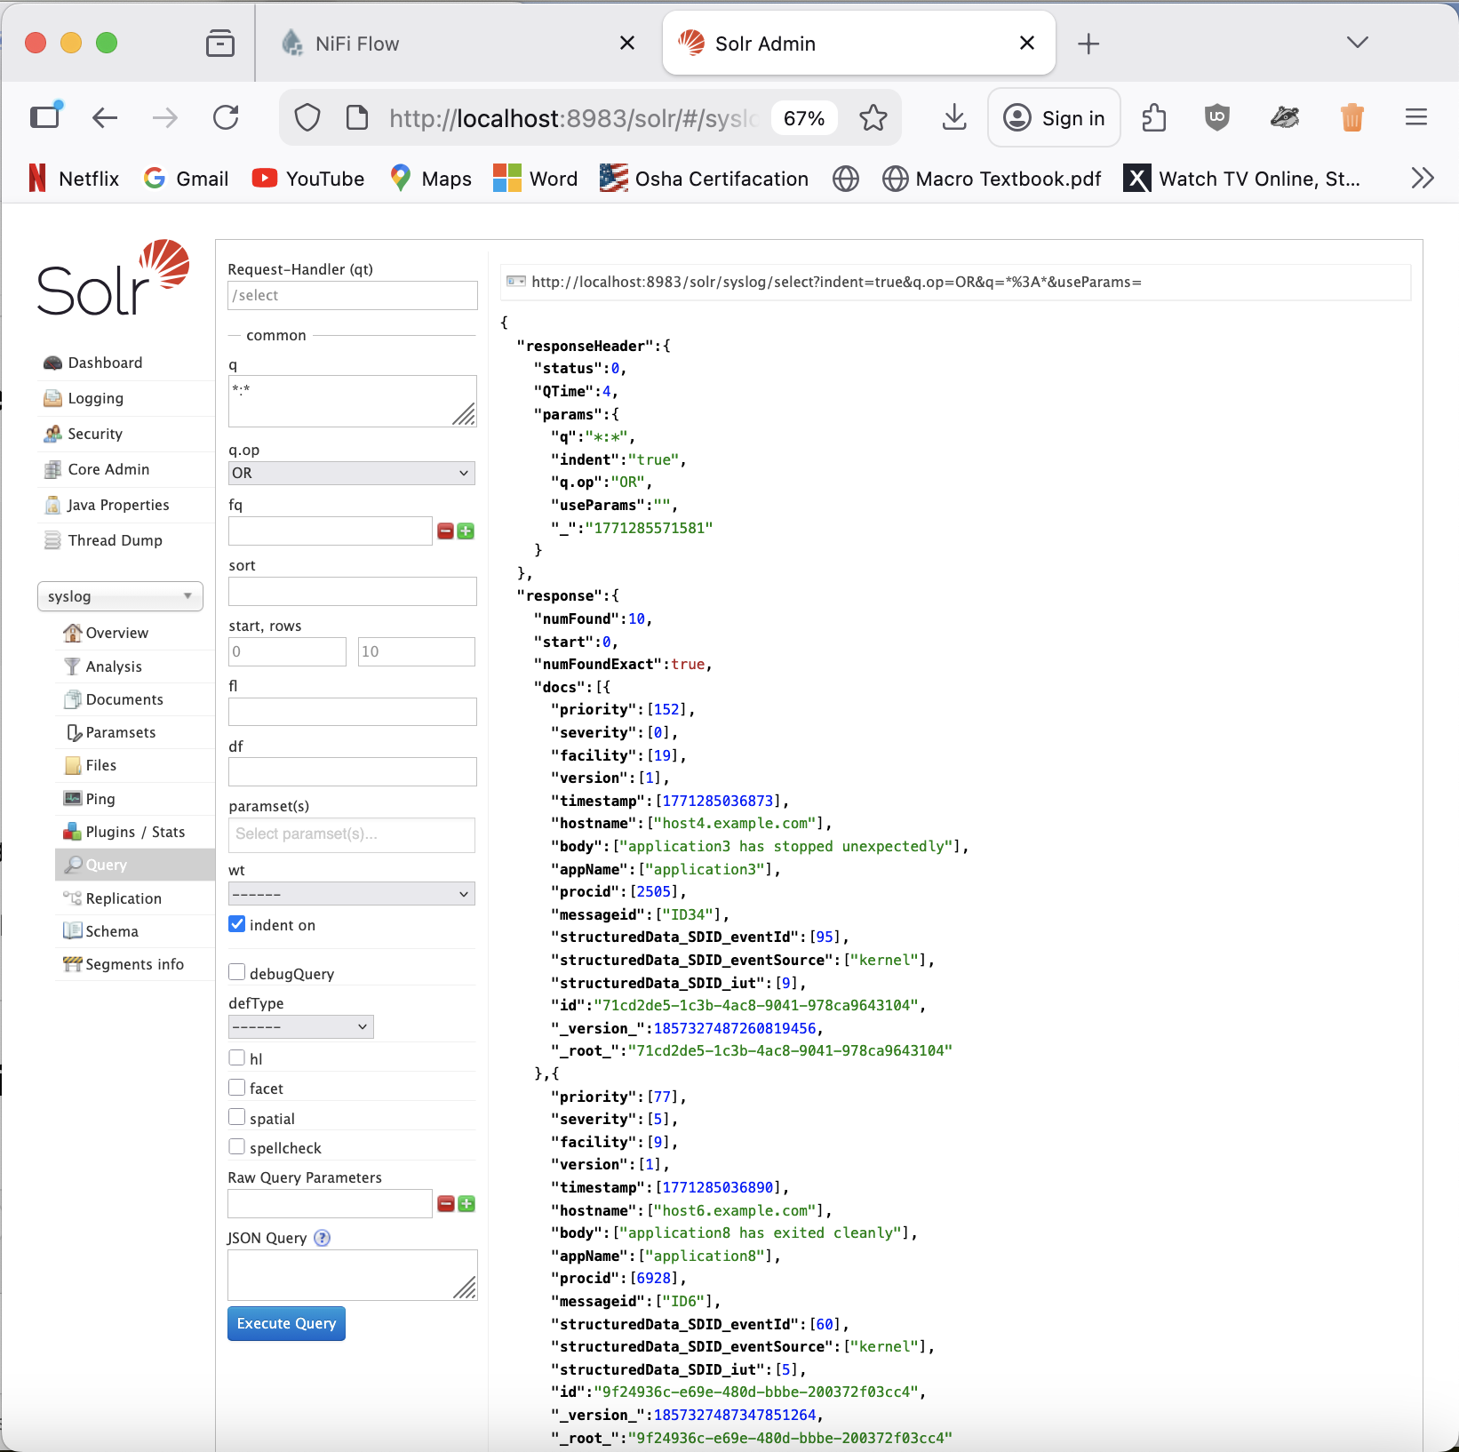

In the q field, severity:3

This query all the severity level error. For syslog, Error = 3, so it returned 3 documents. From the results, the documents show things like hostname, timestamp, message, process and more.
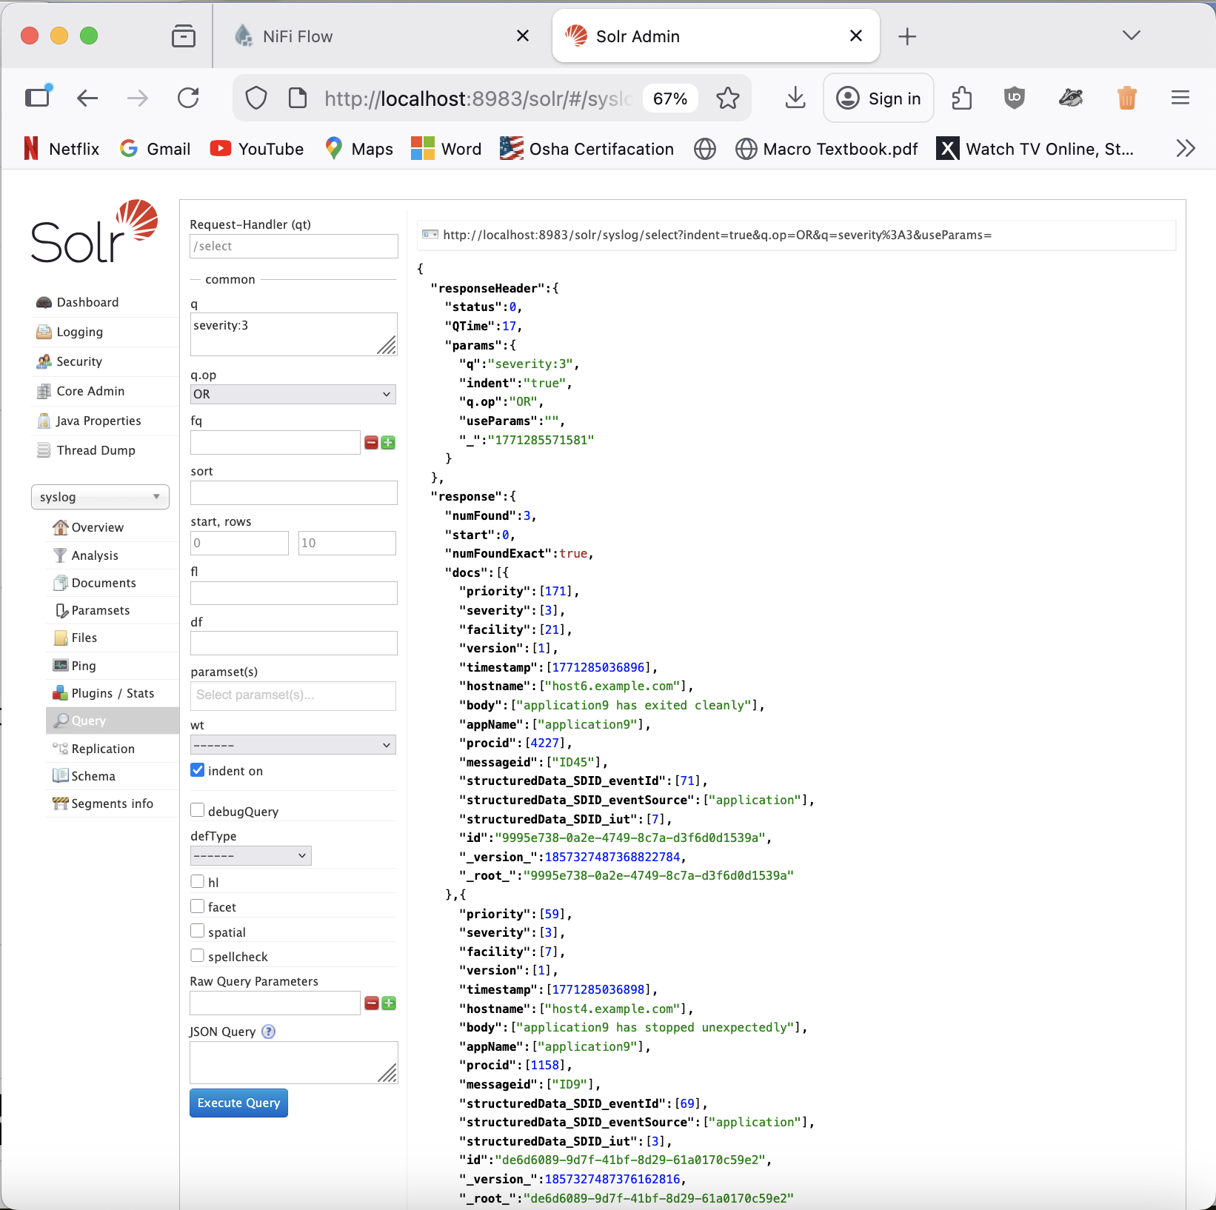

In the Sort field, timestamp desc, orders the results by the timestamp field in descending order.

Row, 20, means it will show only 20 documents / log entries.

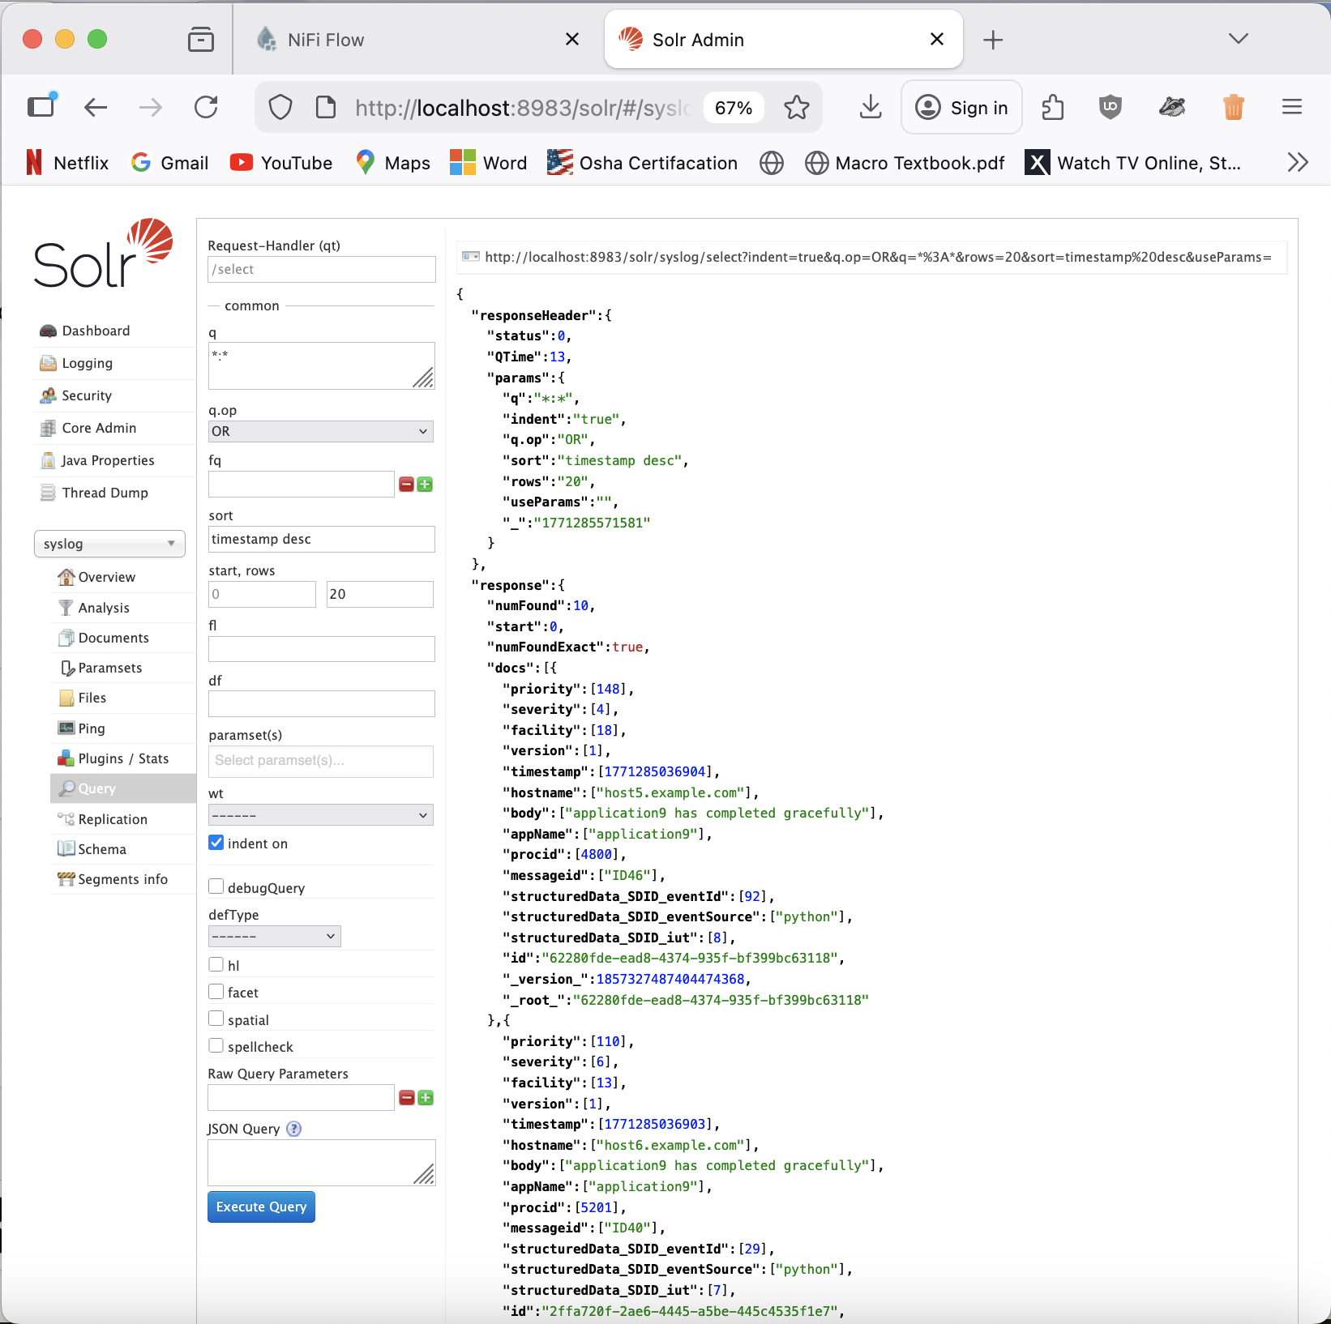

Fl field - *,score
Row, 5

Fl lets you pick which fields you want to make it cleaner and faster.
This query returns the fields with a Solr relevance score. Then I also only looked at 5 rows.

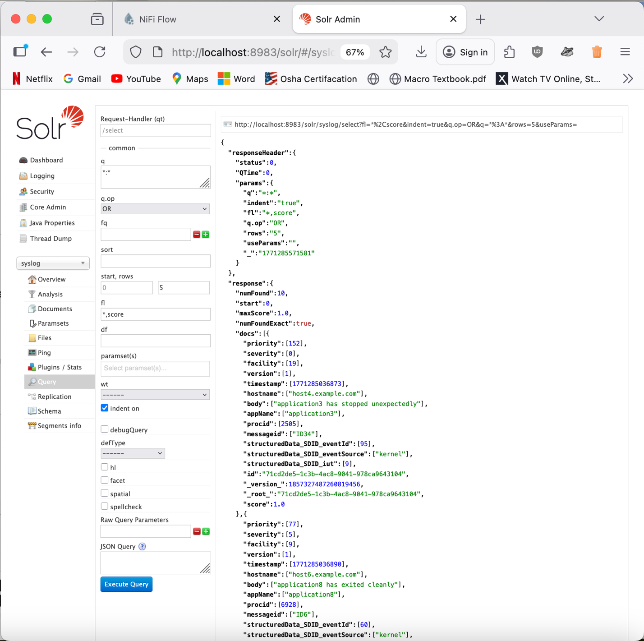

Shutting Down.
